Implementaions

Flow of the web application

1. Home page:

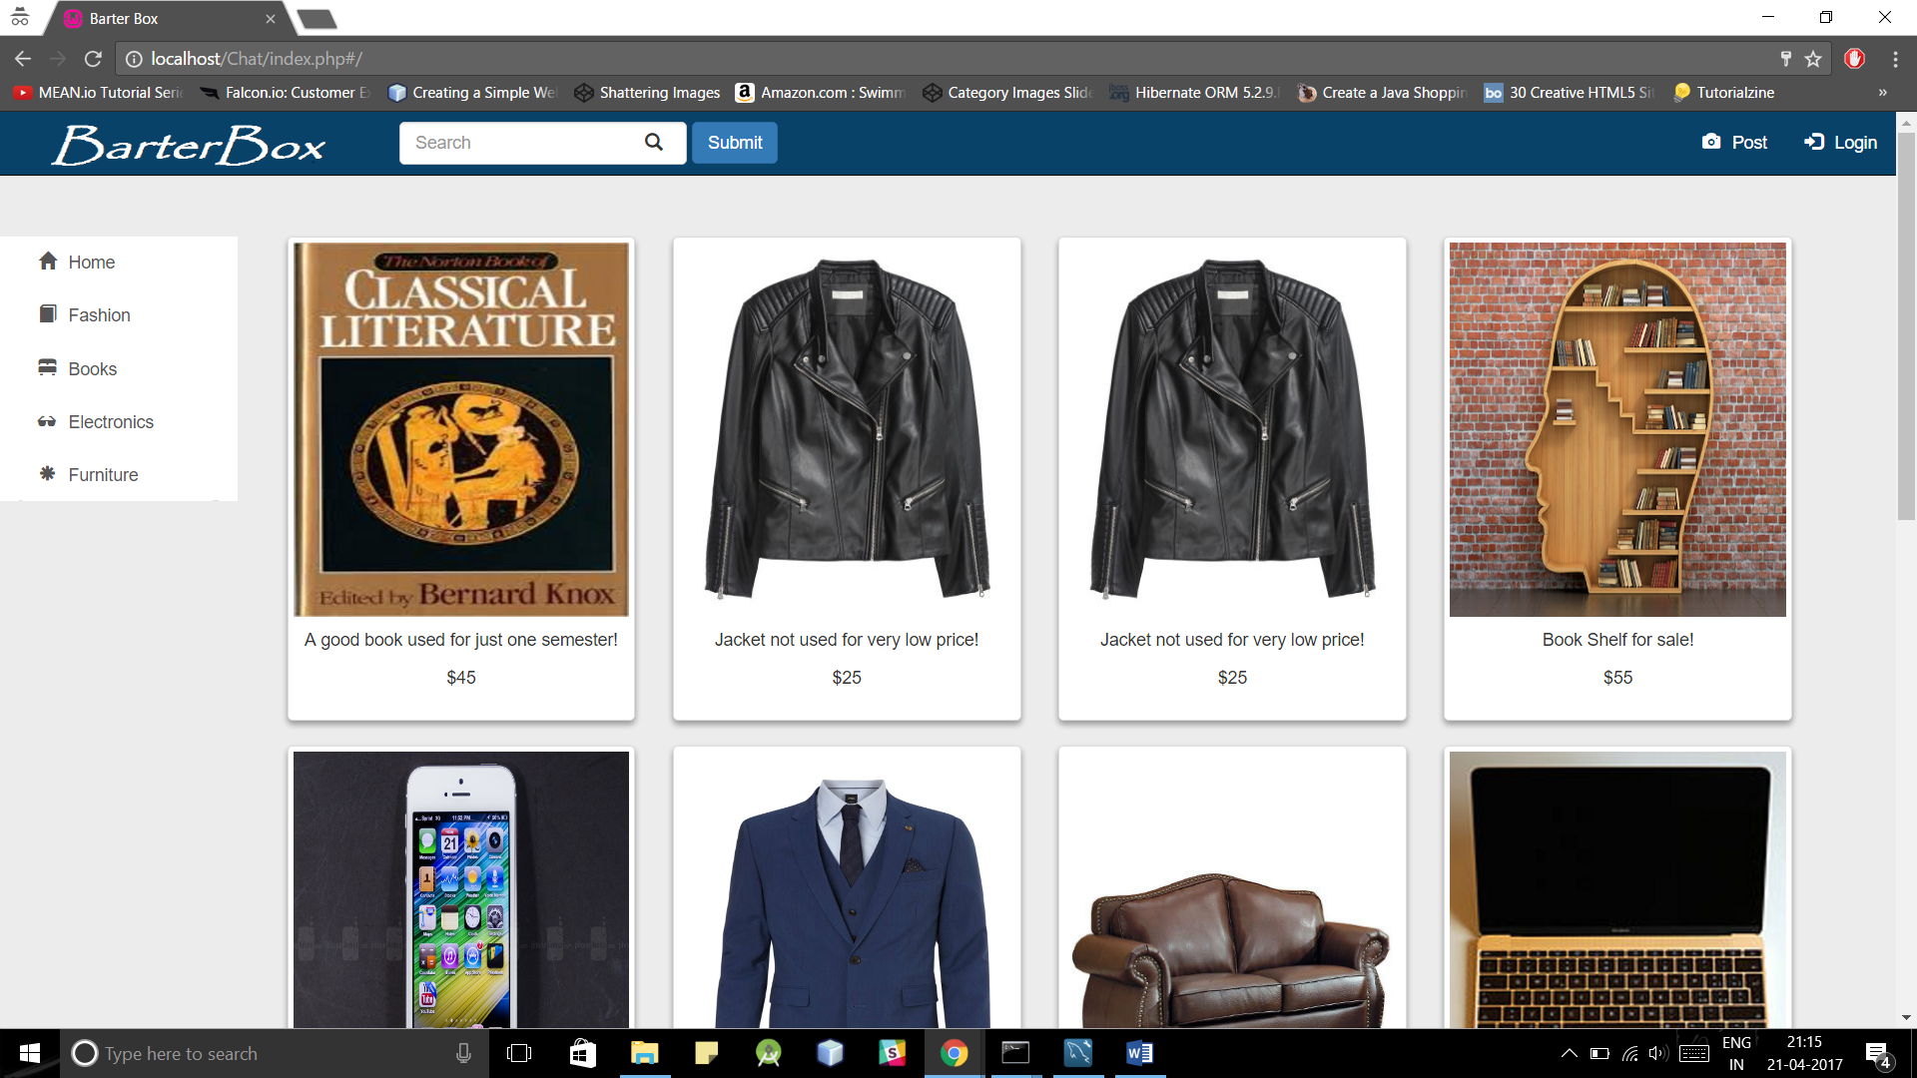

1. Search using angularjs(search filter):

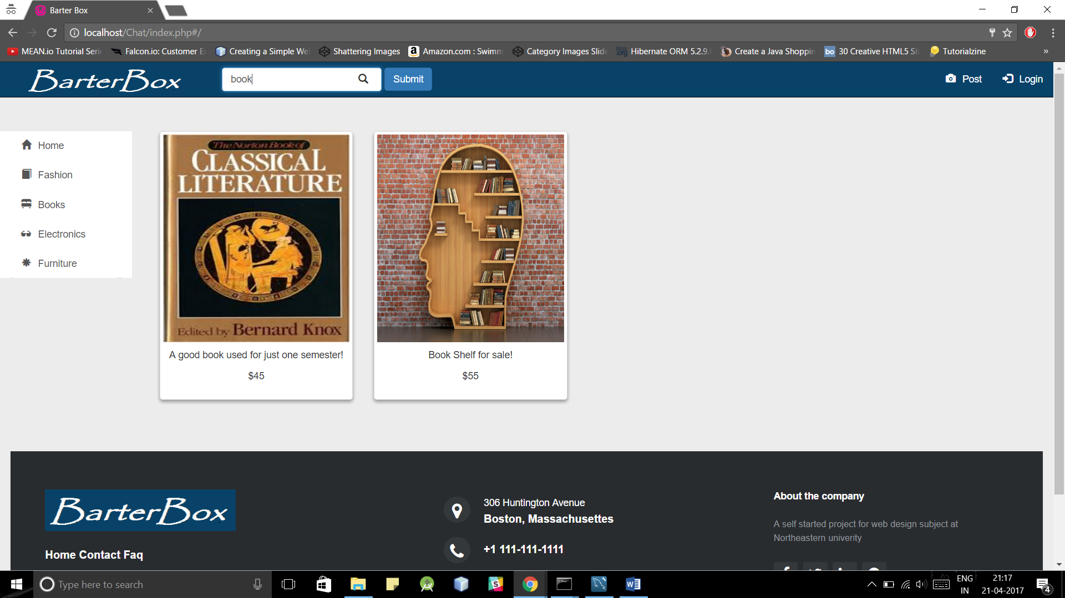

1. Post product using jquery:

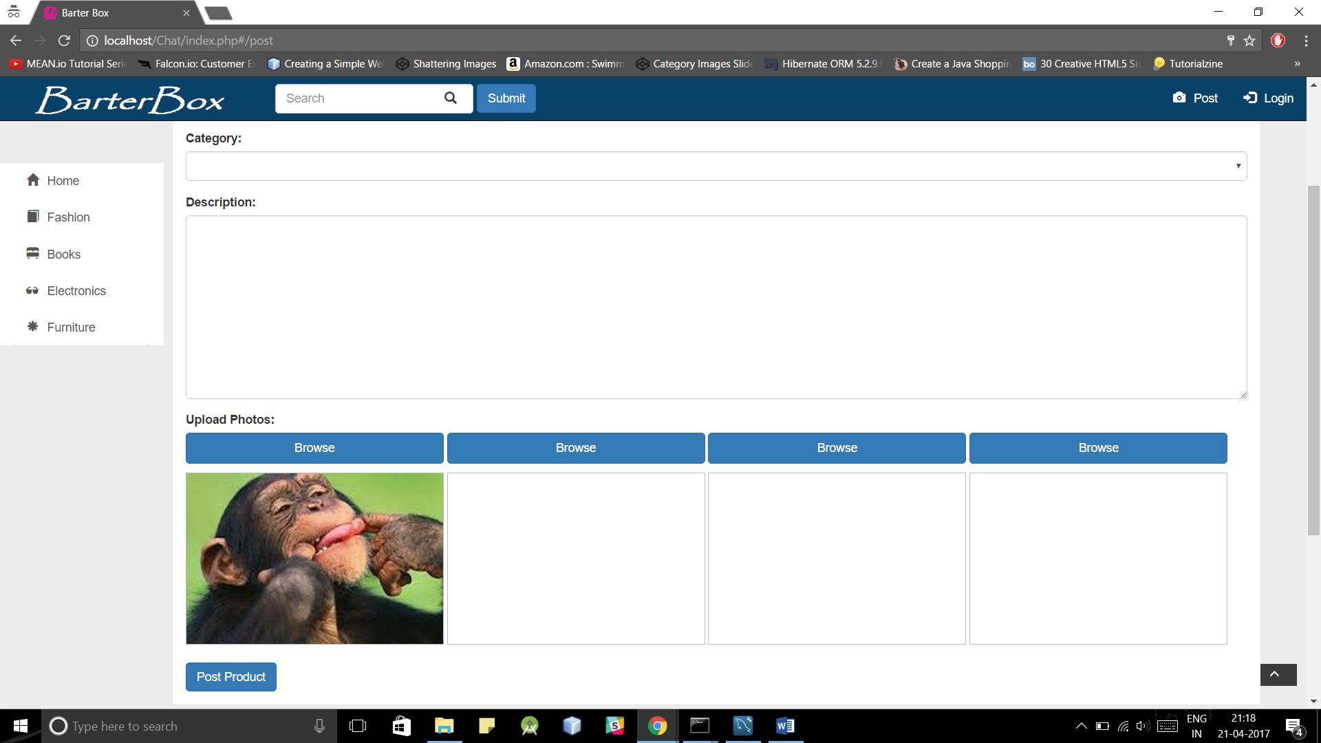

1. Register user page can access through login model view nd inster that new user register user

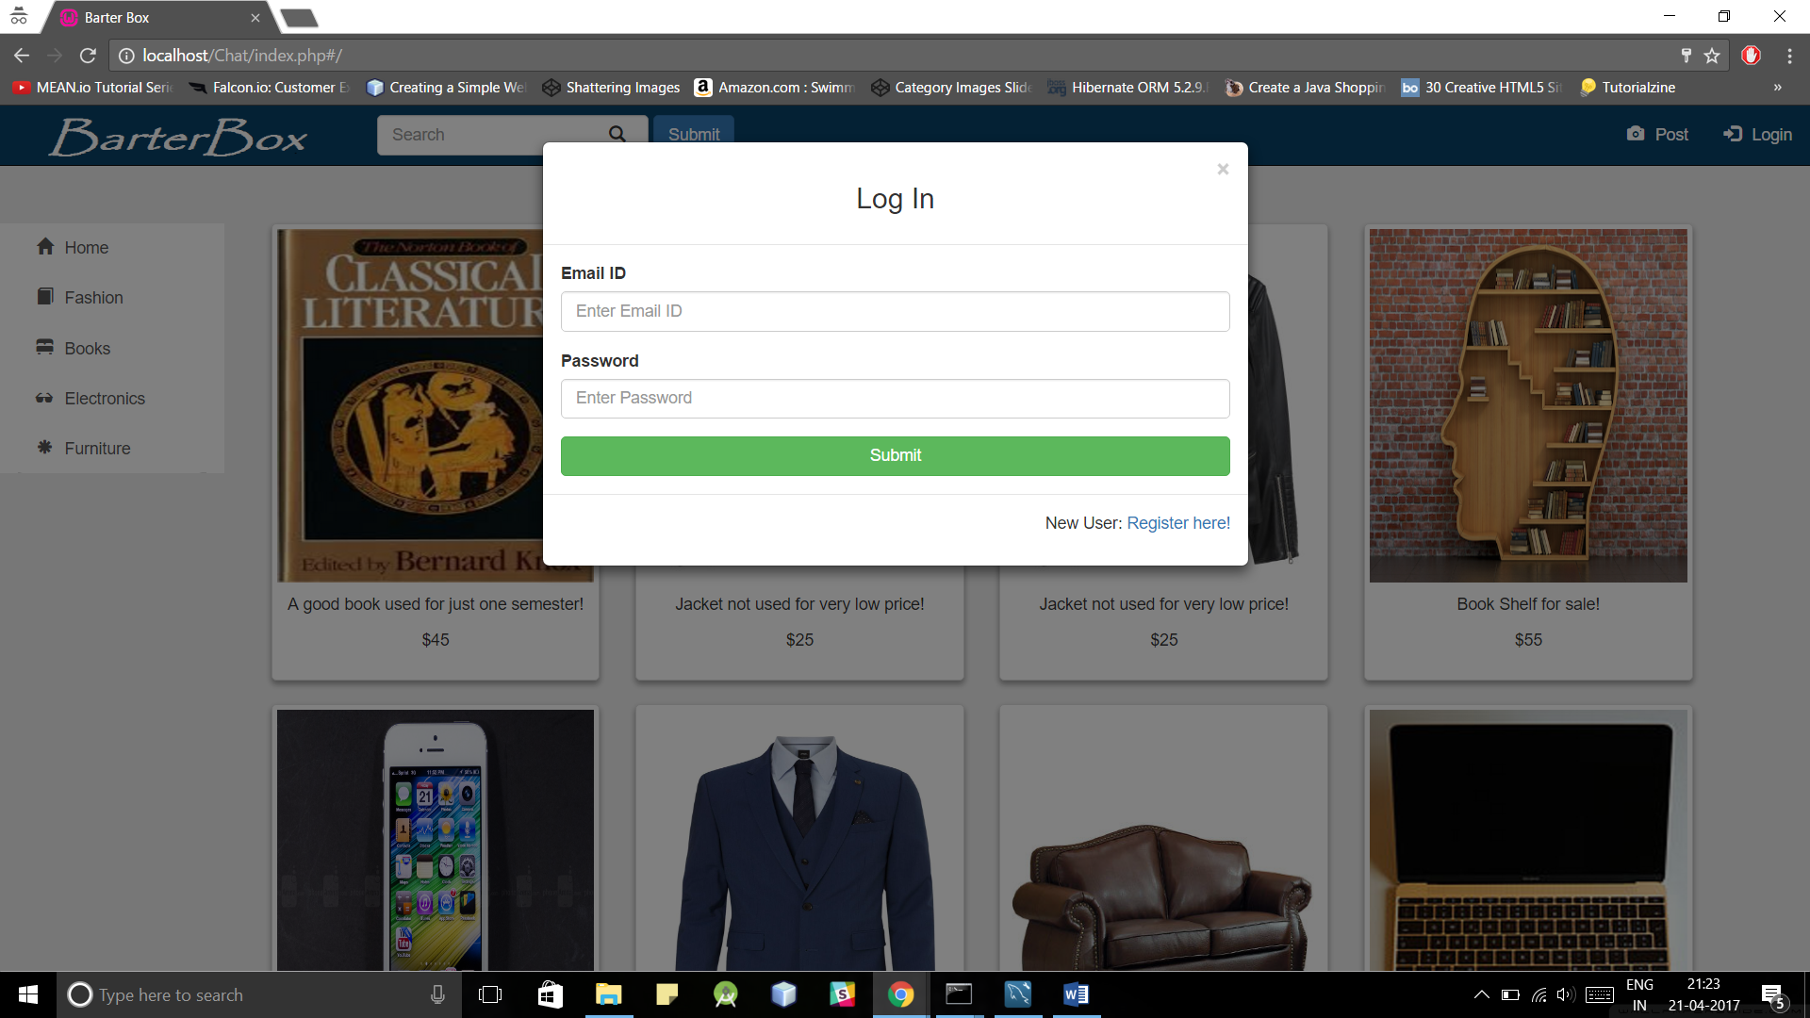

1. Register user

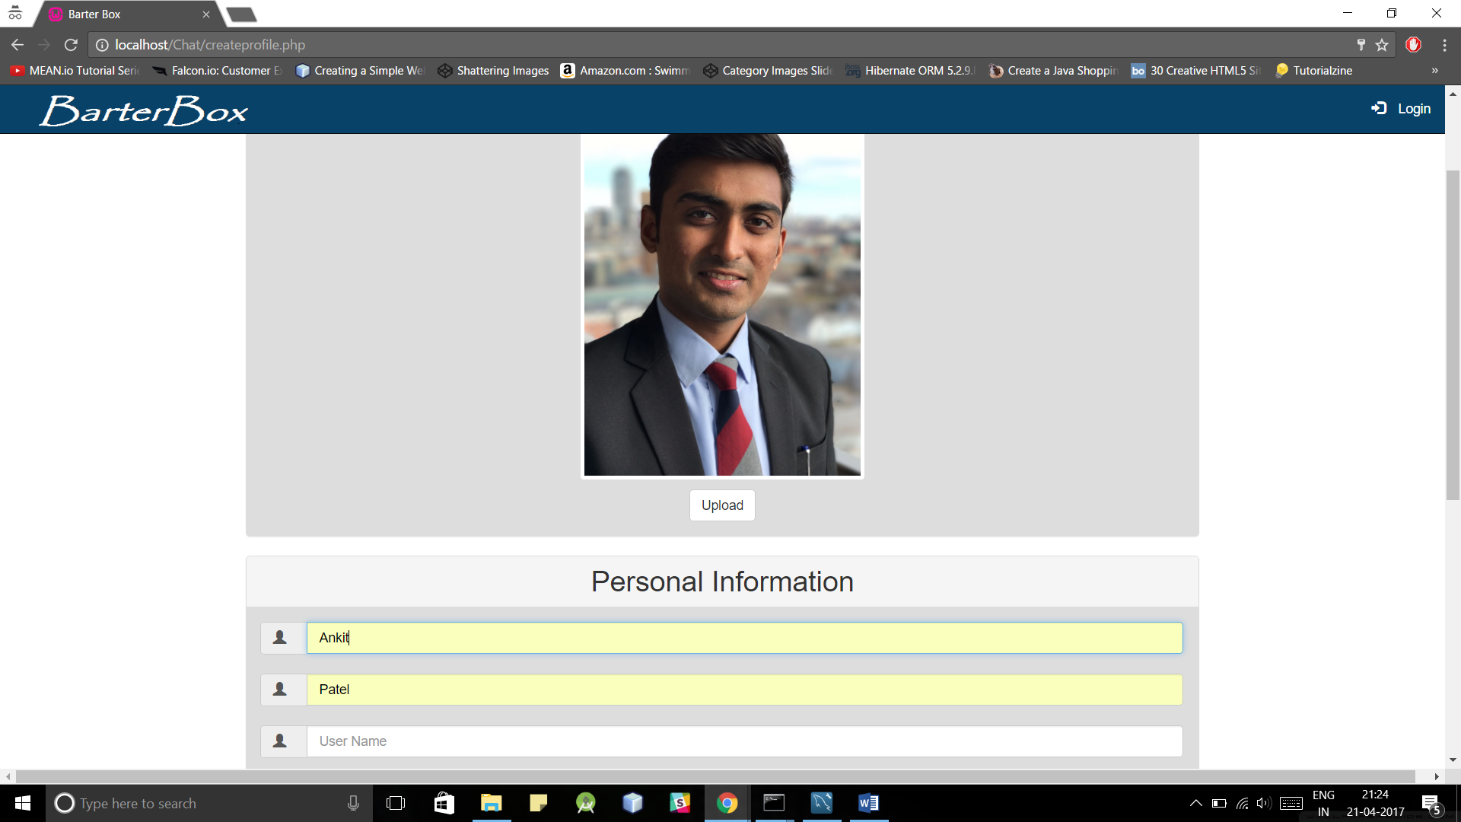

Error done using jquery

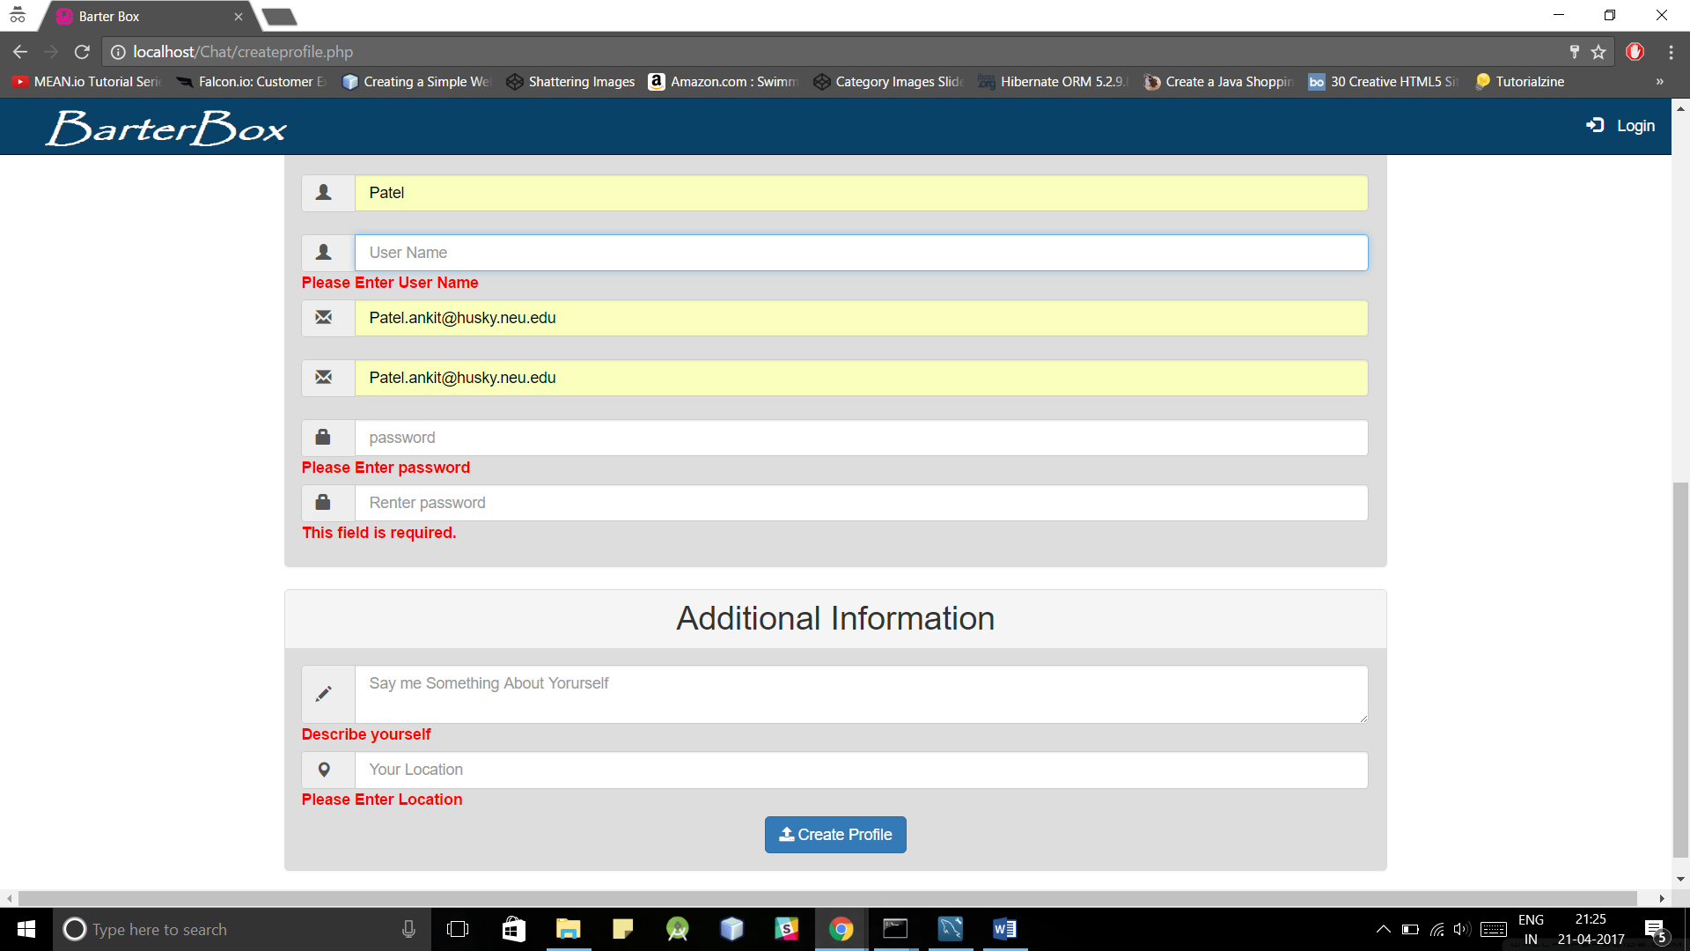

1. Product details

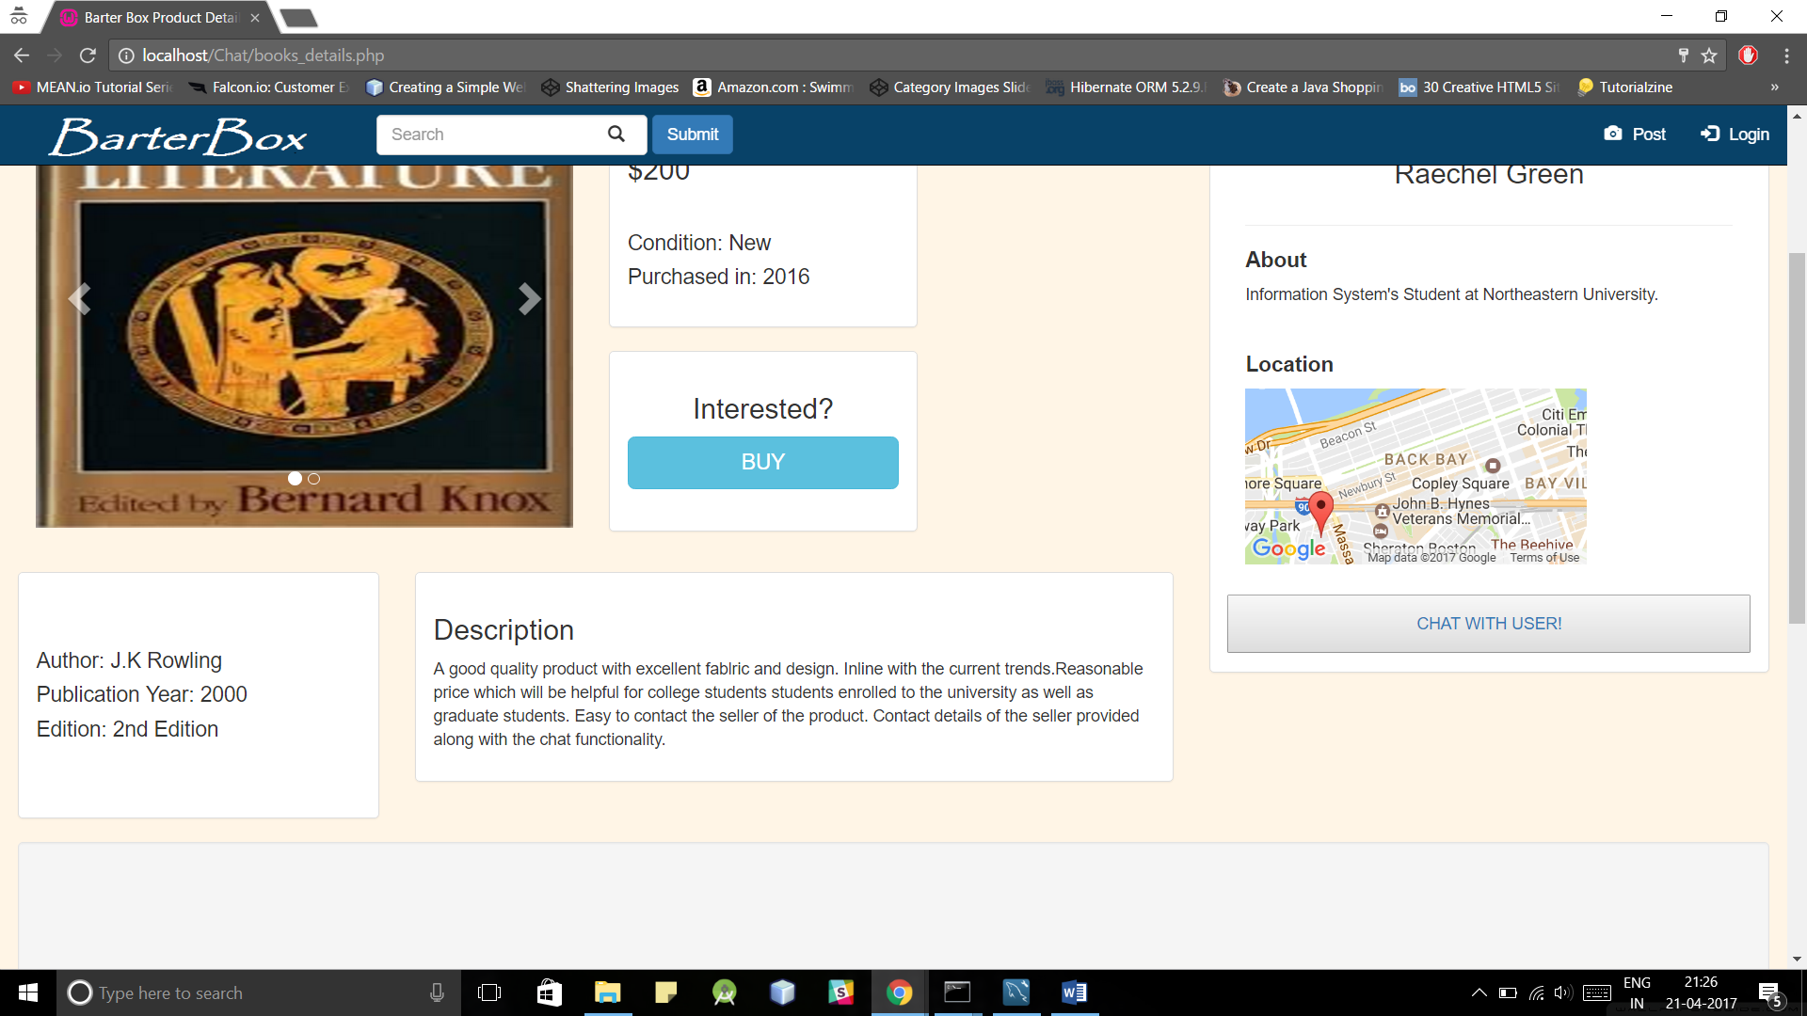

1. Chat confirm details page

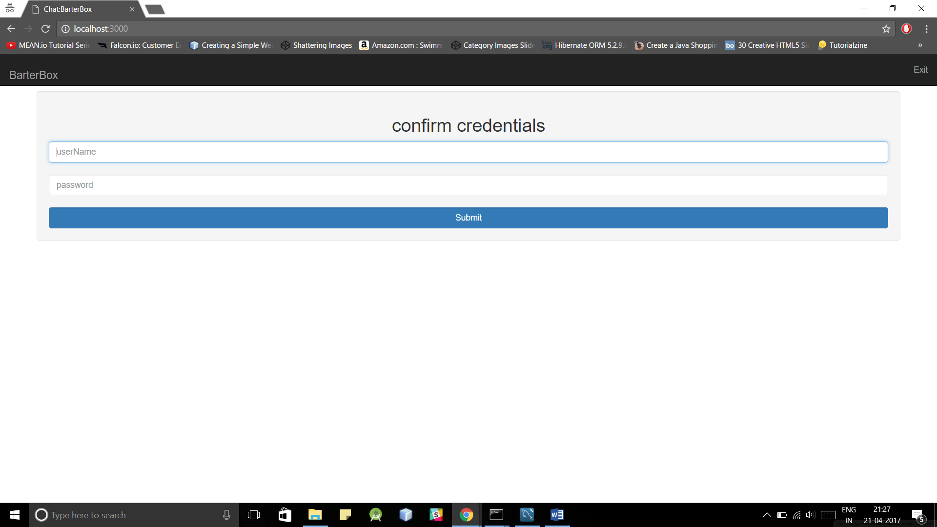

1. Chat home page (user name can be anything that you want to display and password can be any characters)

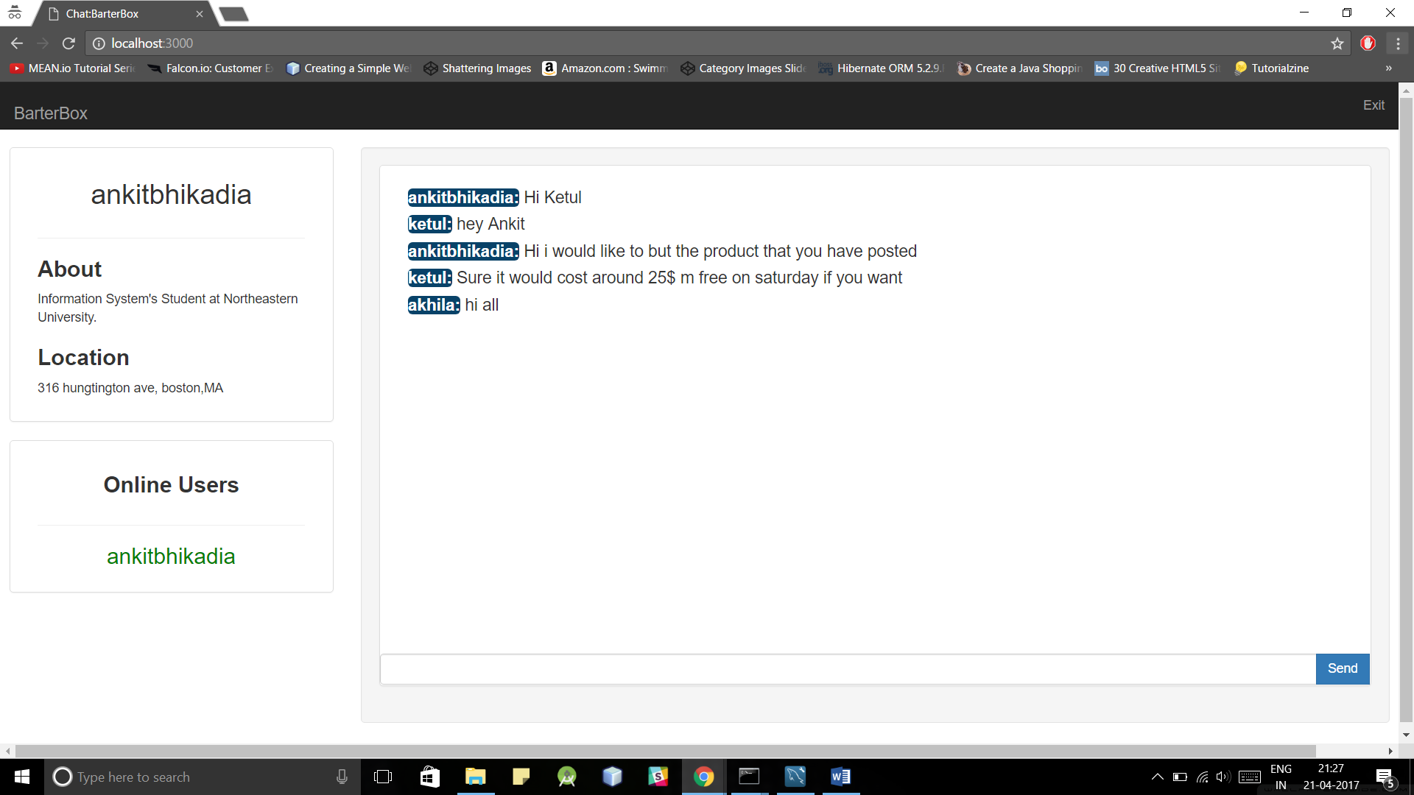

1. Can add as many users as you want and can be see below in the online user tab

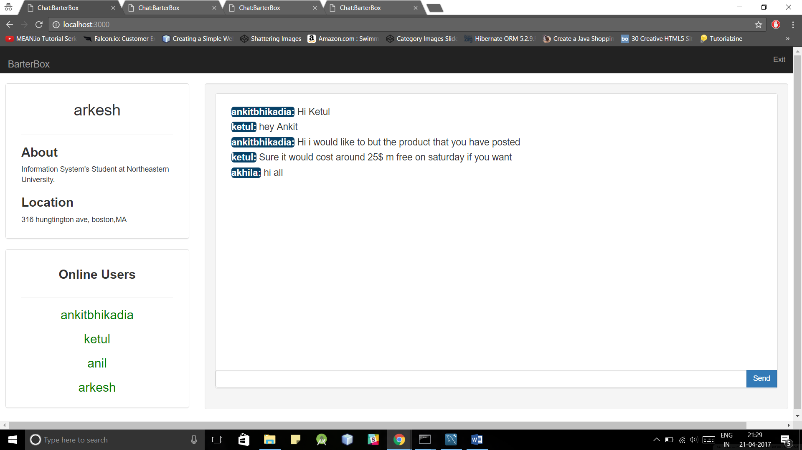

1. Can send private message

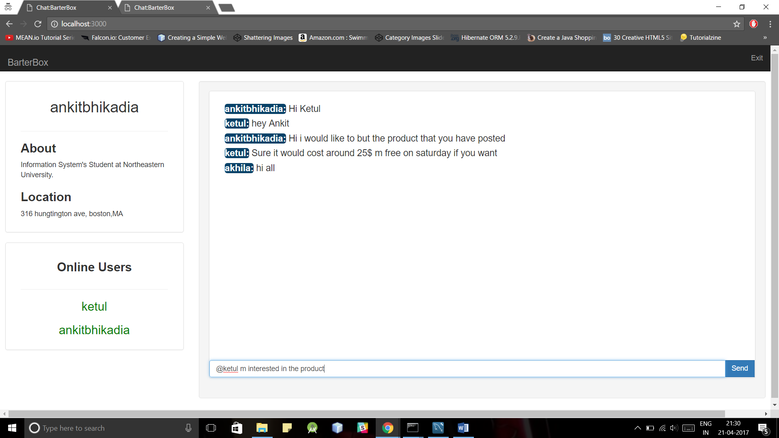

1. User who gets private message can see it in lightblue tags

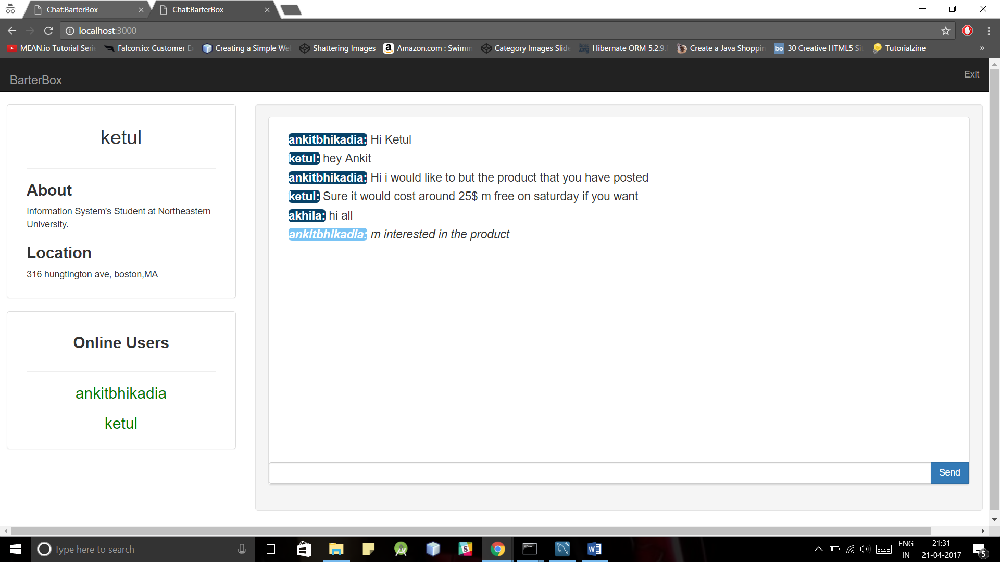

**Part done by Akhila Kunche and Mrunalini Diwale(together):**

**Technologies used: HTML, CSS, Javascript, Bootstrap, PHP, jQuery, Angular JS, MySQL, Ajax**

There are four different categories namely:

Fashion

Books

Electronics

Furniture

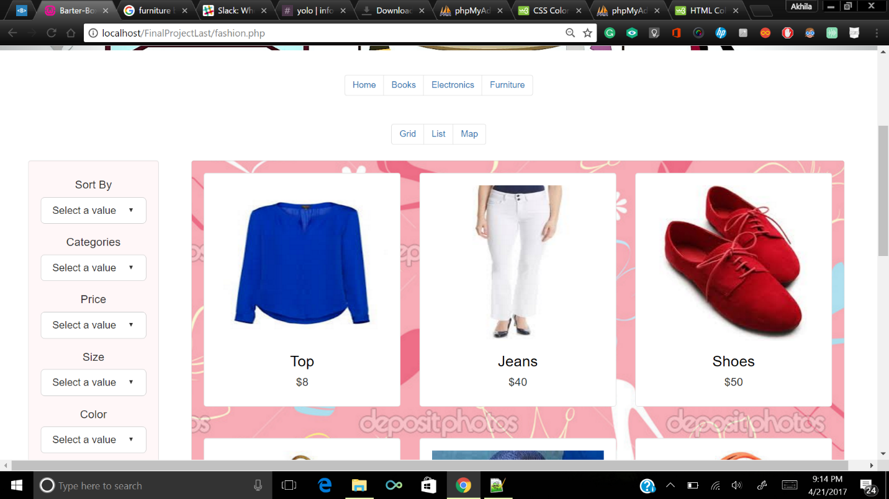

Each category is implemented in a different page since there are four tables, one for each category.

Each category has individual features based on which one can sort and filter based on:

Price (High to Low)

Price (Low to High)

Newest product

Filter by:

Color

Size

Sub-categories

Price range

Filter and sort is implemented using PHP.

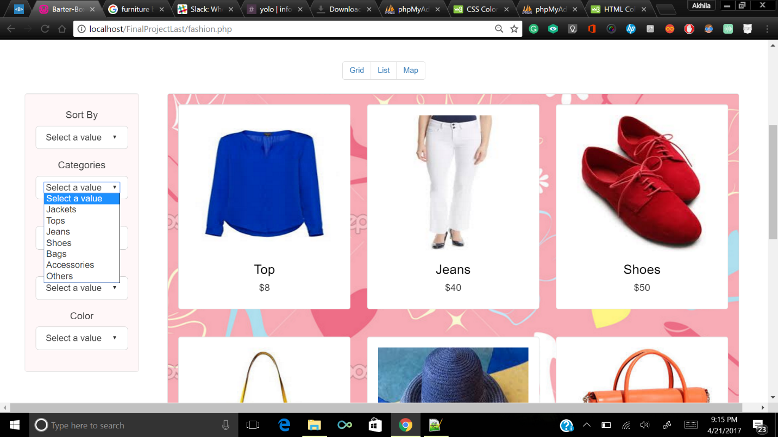

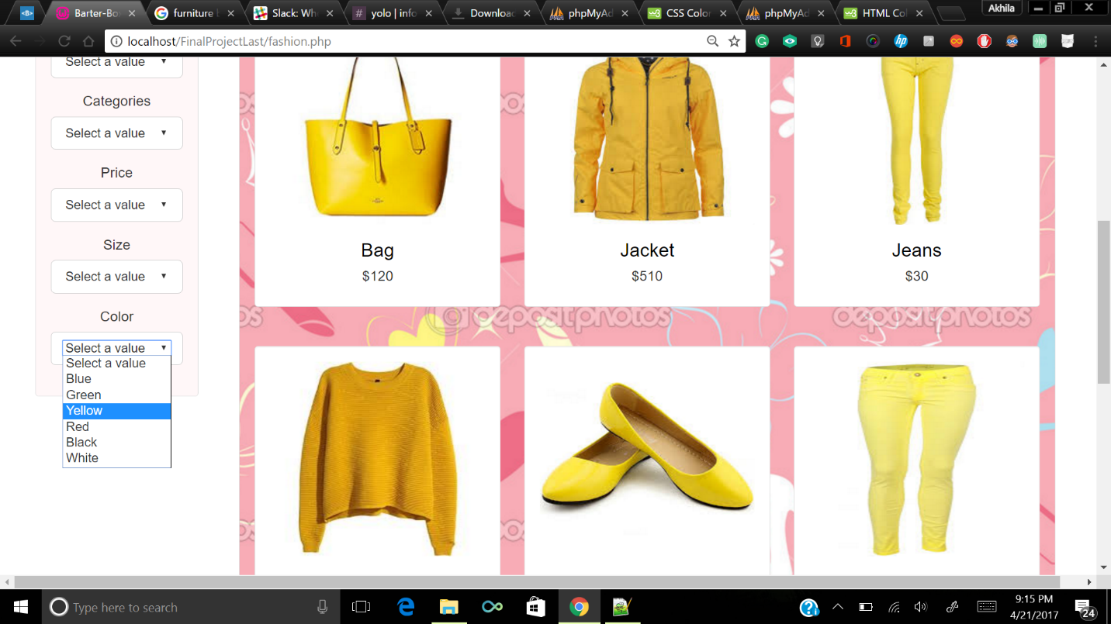

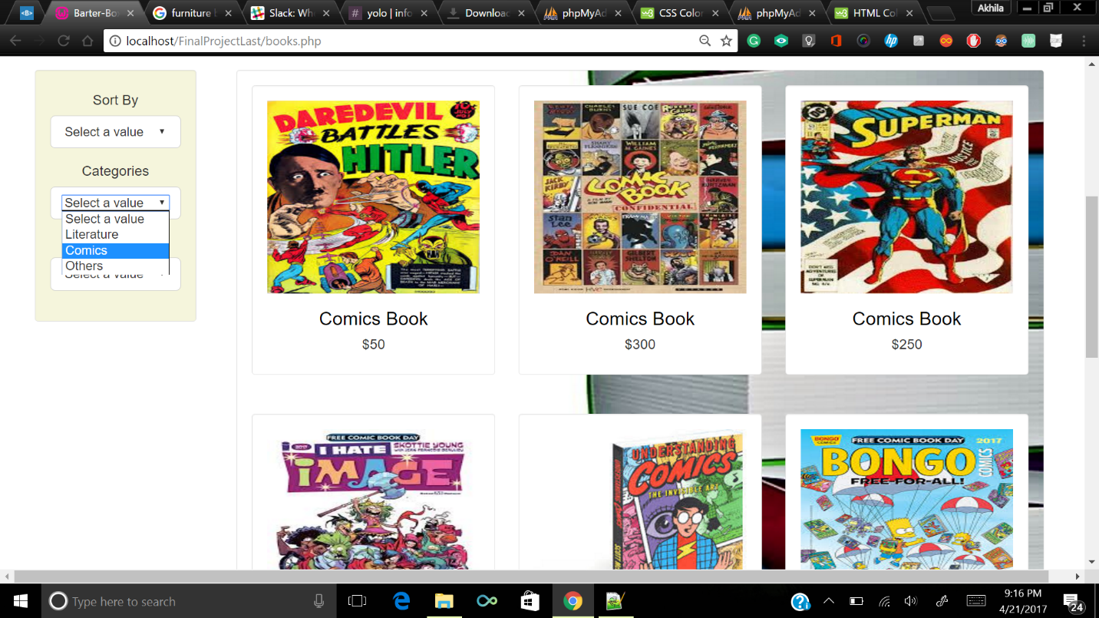

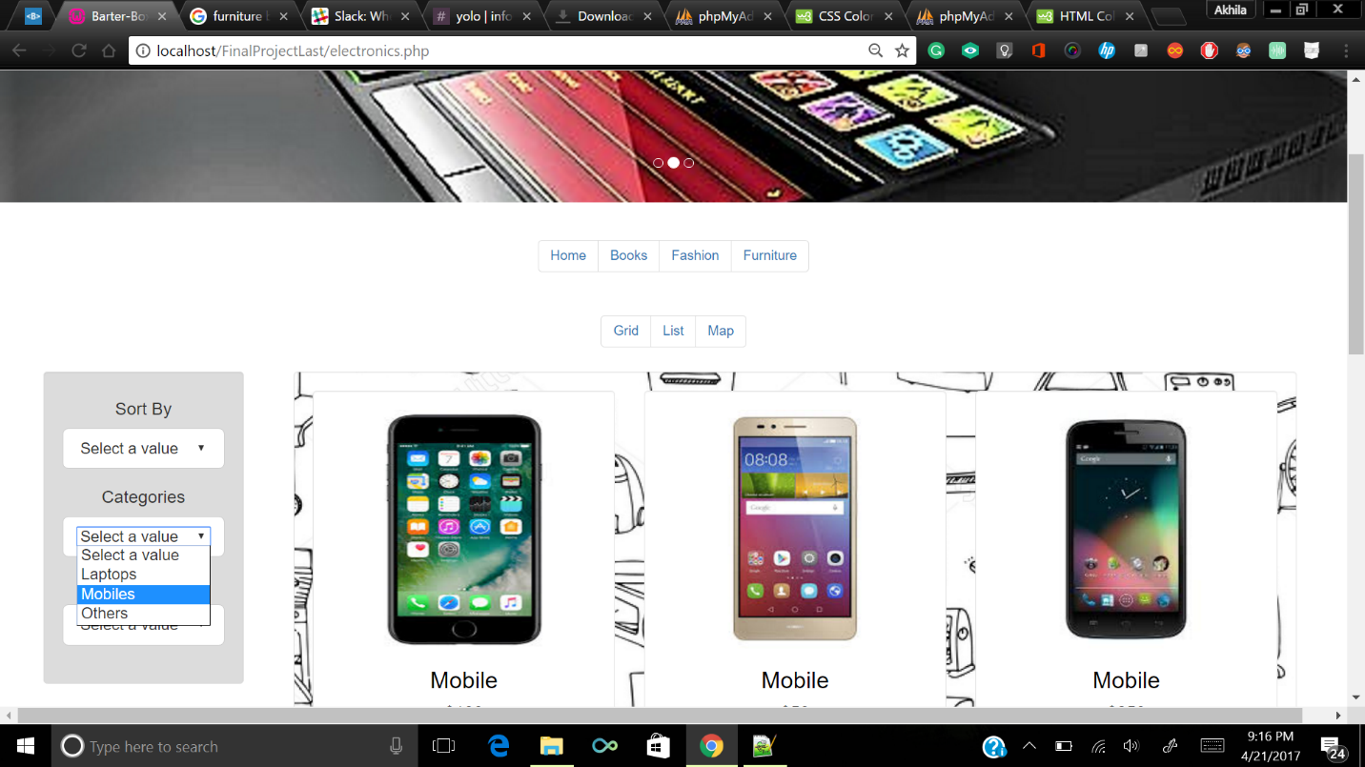

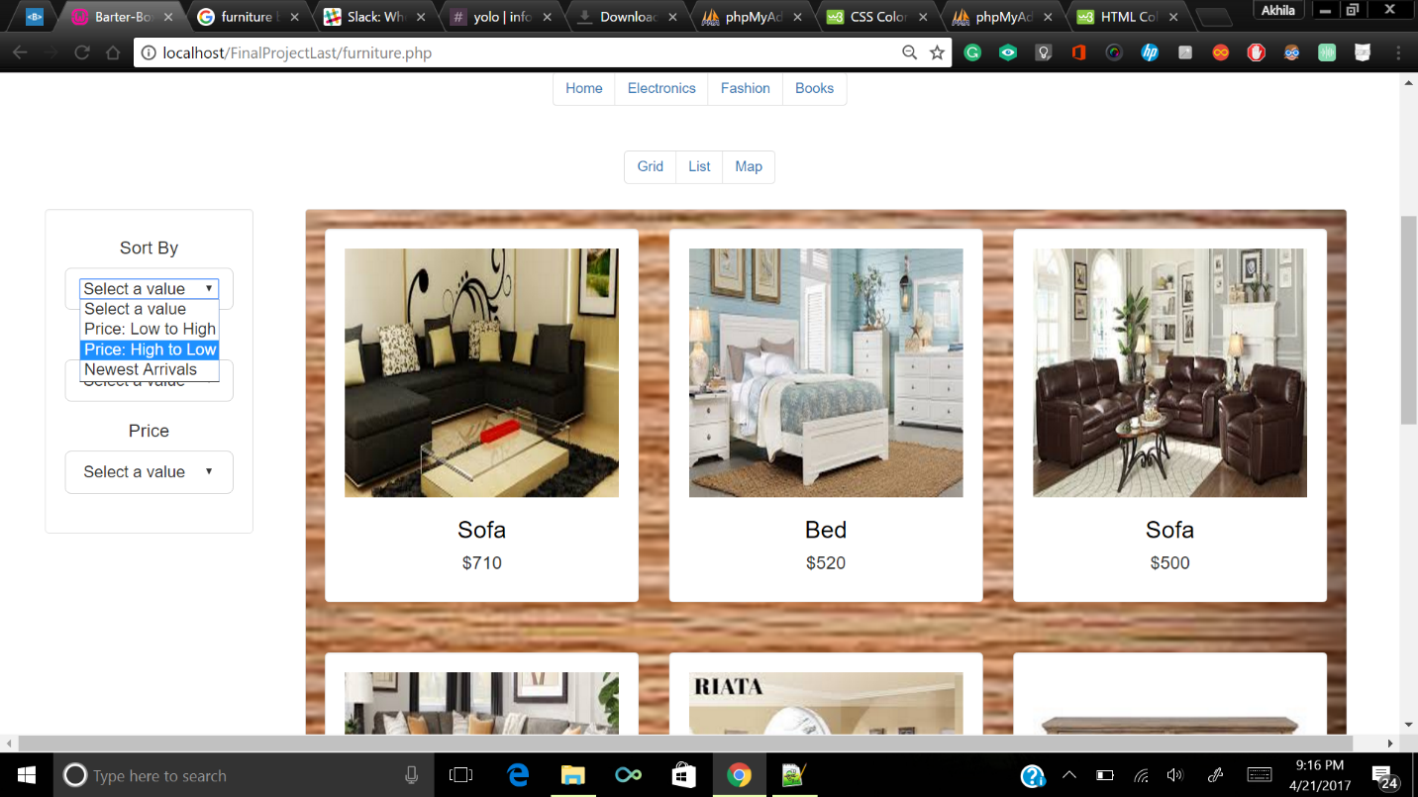

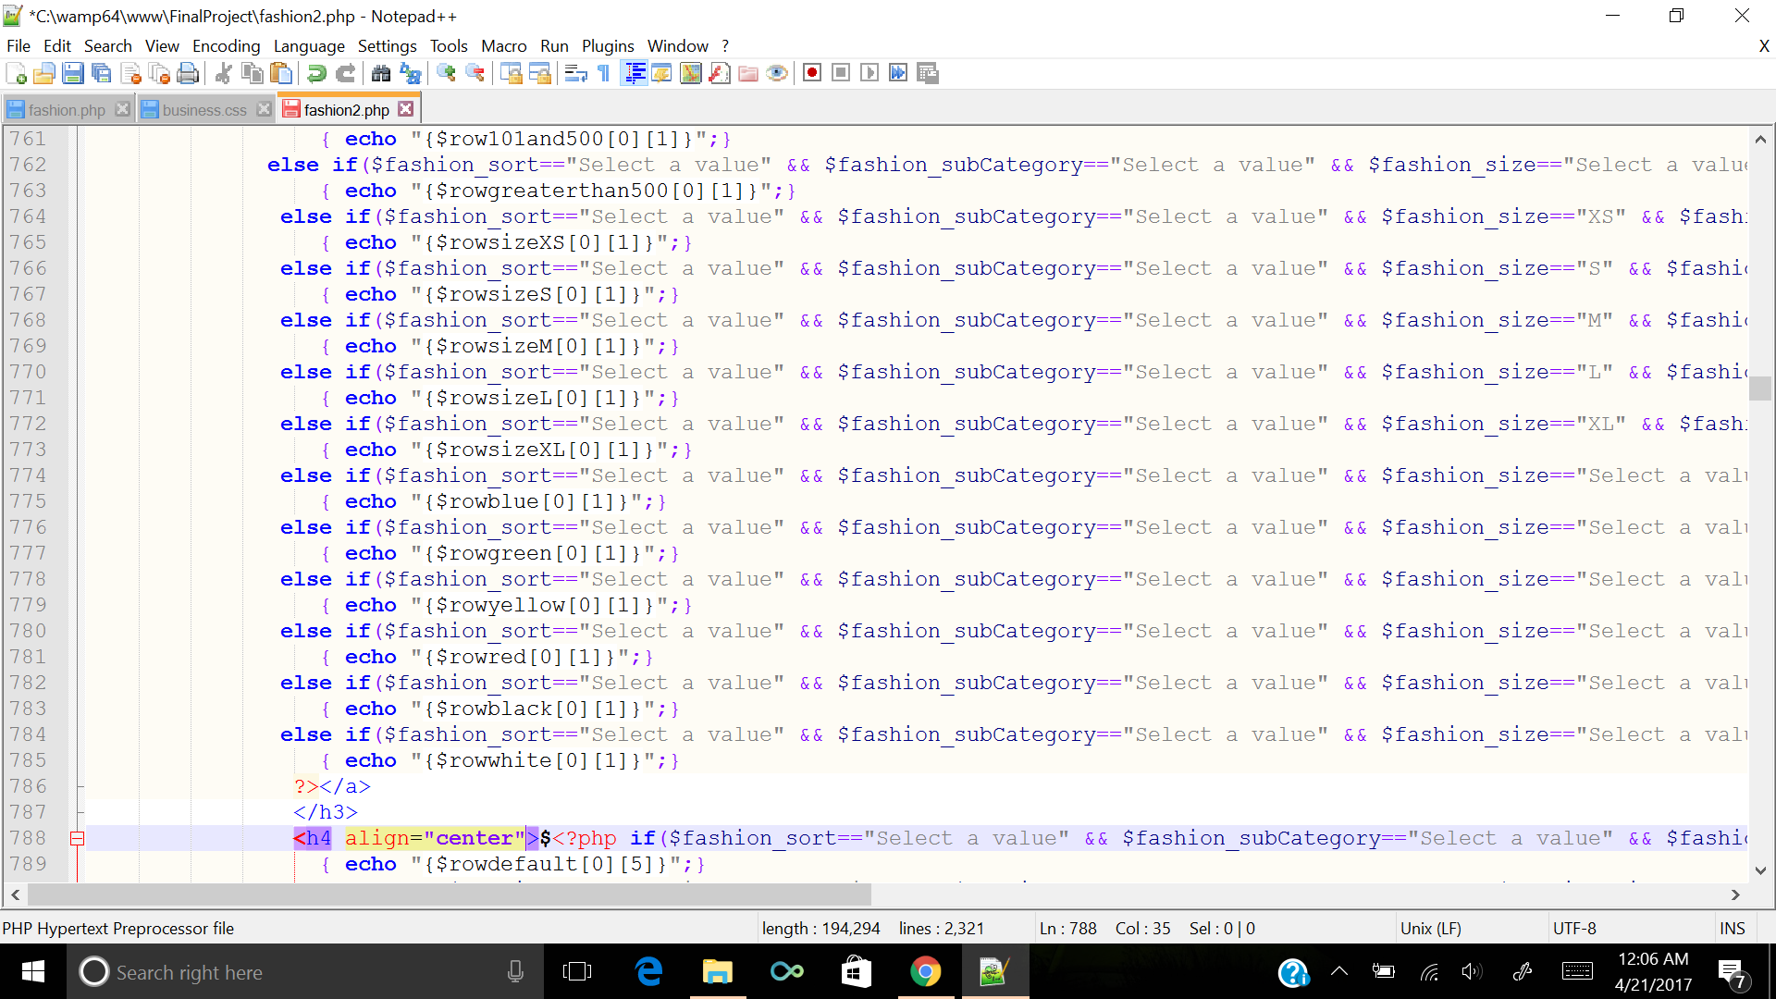

The products can be displayed in two different layouts - Grid and List.

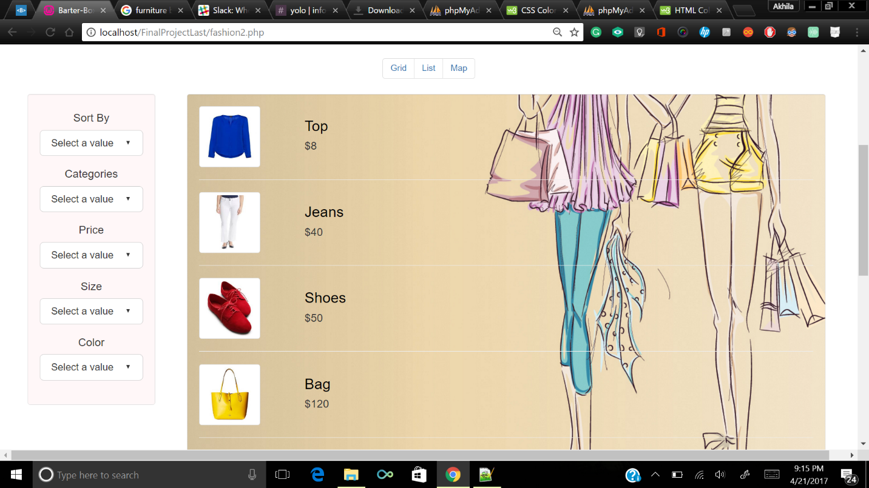

There is a Map view in which different locations are pointed using markers (using Javascript and Google maps API)

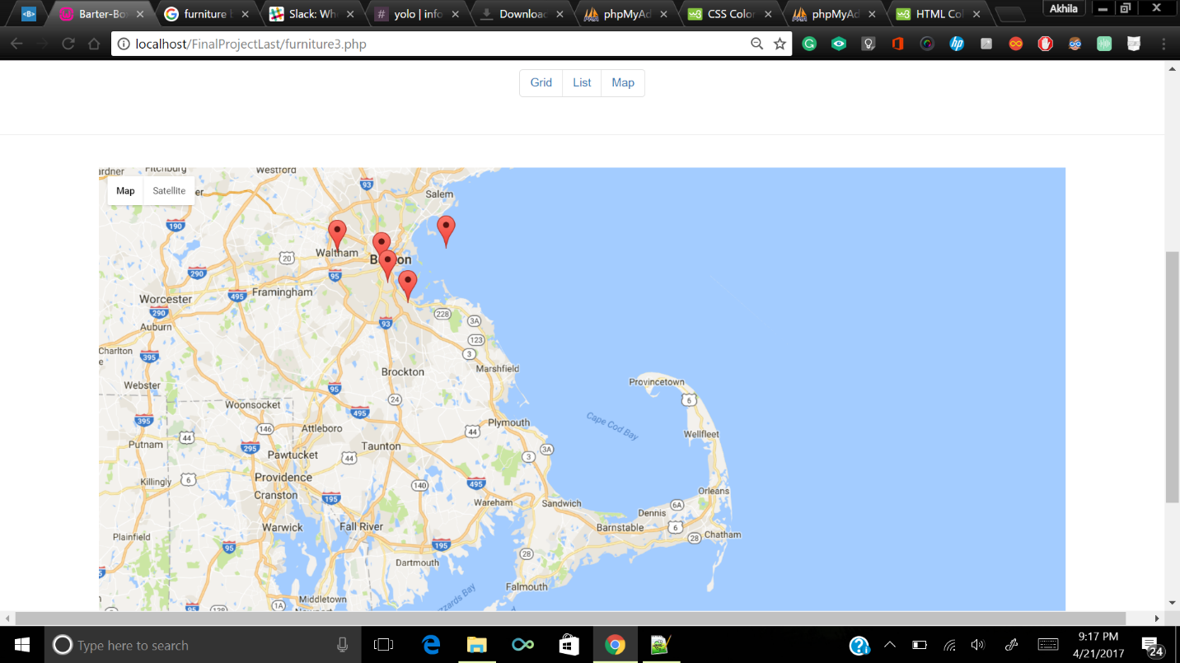

After clicking on any product, details of the product can be seen.

There are four different pages to show the details of each category.

In product details page, based on the category, individual features of the products are fetched from the database using PHP.

Information of the seller is displayed along with his location (on map with a pointer)

There is a BUY option if a user is interested in the product. A notification will be sent to the user.

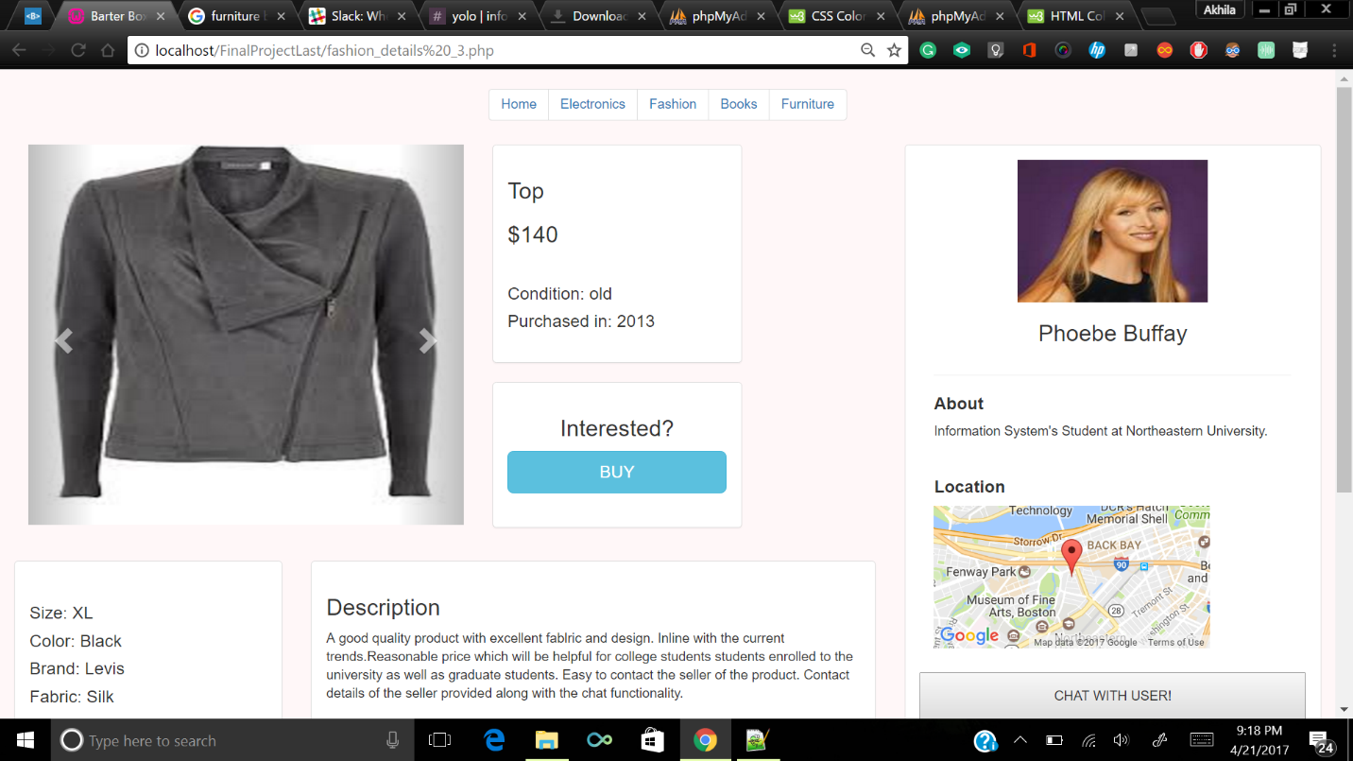

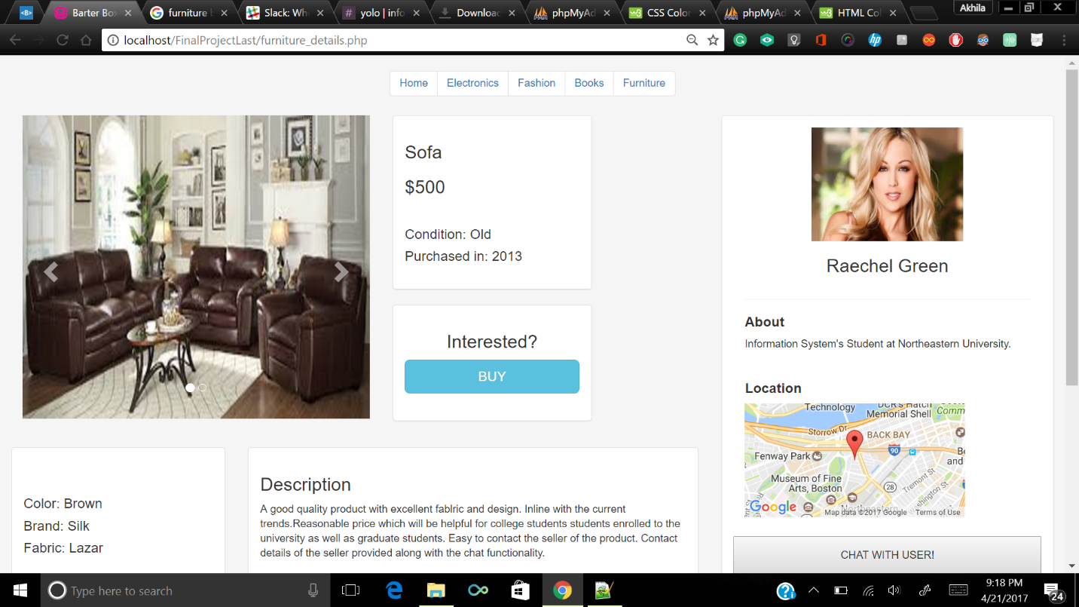

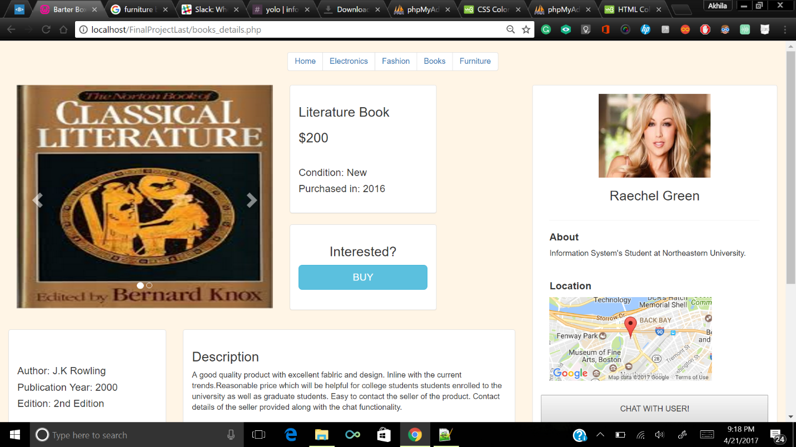

There is a BUY option if a user is interested in the product. A notification will be sent to the user.

There is a help option to see the frequently asked questions.

Based on the product, similar recommended products are displayed. User can click on any recommended product to see the details.

